Delphi Web Studio User Guide
A control by control reference for the Windows application
Last changed: November 6, 2026
Source based illustrated edition
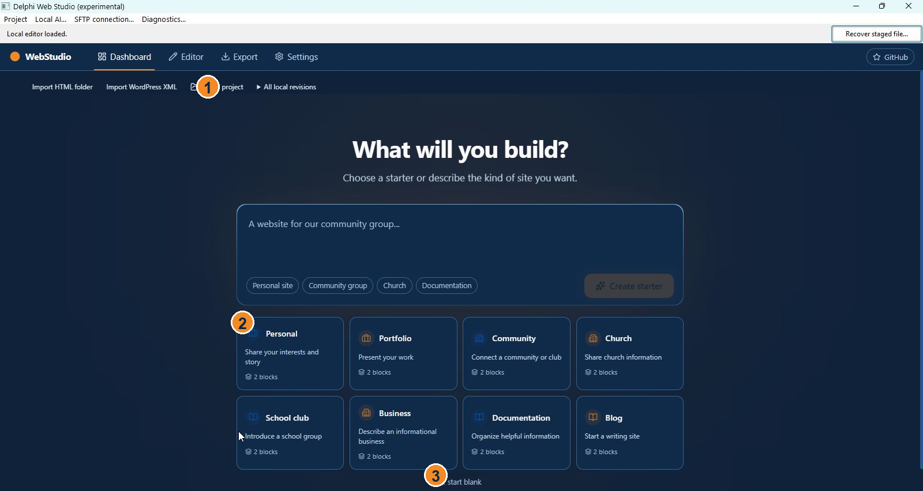
A guide to the current Delphi Web Studio application.

Contents
About this reference 3
Windows application and Project menu 3
Main navigation 3
Dashboard project creation 3
Project file controls 4
Editor screen and page tabs 5
Editor toolbar view controls 6
Components and Layers panels 6
Properties panel and section types 6
Design panel 8
Media panel 8
Articles panel 9
Settings screens 9
Export and local review 11
Local AI dialog 11
SFTP and deployment review 12
Practical first project 13
Adding decorative lines 13
Selecting and arranging objects 14
Saving and closing safely 14

About this reference
This guide is organized by the controls on each screen. Find the area you are looking at, then read the matching control. Some controls appear only when a project, page, section, or file is selected. The example screenshots use a fictional project; your content will differ.
Project files are editable working copies. Website exports are separate output. Saving or reviewing a project does not publish it.

Windows application and Project menu
Status area: Displays startup, operation, and recovery messages. Read it if a native dialog or download reports a problem.
Recover staged file: Select a retained .webstudio-download temporary file and choose a new project filename in the same folder. The application makes a preliminary format check; reopen the recovered copy to determine whether it is complete.
Project > Back up project: Choose a saved JSON or ZIP project and a destination for a checked recovery ZIP. This is a separate backup of a file you already saved.
Project > Restore project backup: Select a supported recovery ZIP and write the recovered project to a new filename. Open the restored file and check it.
Local AI: Opens the optional local model dialog for an open editor project. It is separate from a Google API key.
SFTP connection: Opens the connection and destination tools. Opening the dialog does not publish a website.
Diagnostics: Shows local diagnostic information about the application environment. It is not a complete product or website health test.

Main navigation
Dashboard: Returns to the project dashboard. Save a portable project when you need an independent copy; dashboard drafts use local application storage.
Editor: Opens the editor view for the selected project.
Export: Opens the local website-output and review view. Export is not a project save.
Settings: Opens project settings for general information, search metadata, and optional keys.
GitHub: A link to the application repository. It is not a setup wizard or publication button for your website.

Dashboard project creation
Description box: Enter a short description of the website you want to create. Create starter uses this to select a local starting point; it is not by itself a cloud AI request.
Figure 1. Dashboard with starter choices and project controls.
Create starter: Creates an editable project using a local starter. Replace example text and check the pages before exporting.
Starter cards: Choose one of the displayed starting arrangements. Their text and sections are examples for editing, not verified information about your organization.
Start blank: Creates a project with an empty Home page. Use the editor to add sections.
Your projects: Displays project drafts stored in this application's local browser profile. Select a card to open that draft.
Search: Filters displayed project cards by project name.
All, Published, and Drafts: Filter cards by the status stored by the app. A card's status is not independent proof that a live remote site exists.
Rename pencil: Changes the project card name. It does not by itself rename a previously saved file on disk.
Duplicate: Creates another local project with a separate identity and copied media. Check the new copy before using it.
Delete and confirm: Removes the selected local project after confirmation. A short-lived undo notice may be offered. Keep independent saved files and backups.

Project file controls
Open project: Select a supported project JSON or project ZIP. The chosen file is validated and opened as a separate local draft; the original is not silently overwritten.
Save project: Prepare a portable project snapshot and choose where to save it. A project with media can use a ZIP; a project without media can use JSON. Wait for completion and reopen a copy when the contents matter.
Create local revision: Save an additional local snapshot. Revisions are in the local application profile and are not a substitute for a project file on another drive.
All local revisions or project revisions: List available snapshots. Open a snapshot as a separate project, save it as a file, or remove it after confirmation. Removing a revision cannot be undone.
Save unreadable draft data: When offered after a draft-reading problem, saves raw recovery material for later investigation. Keep it private because it can contain project data.
Import HTML folder: Select the folder, read the preview and conversion report, then explicitly create a separate project. Basic text, links and supported images can be converted; complex styling and scripts are not recreated.
Import WordPress XML: Select a supported WXR export, inspect the report, and create a separate project. Review converted pages and import media separately where needed. This is not WordPress theme or plugin conversion.

Editor screen and page tabs
Projects breadcrumb: Returns to the project list. The adjacent project name identifies the currently selected project.
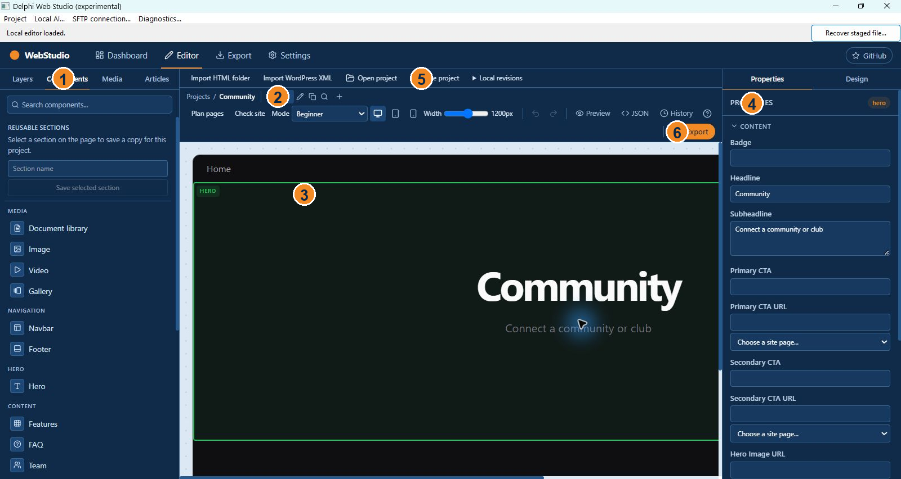
Figure 2. Editor canvas, page tabs, and control panels.
Page tab: Selects the page shown on the canvas. Home is the root page. Editing a selected page does not edit other independent pages.
Add page plus: Opens Page name and Path fields. Enter a meaningful name and a unique valid address, then choose Add Page. Cancel closes the dialog without adding the page.
Rename page pencil: Changes the selected page name. The page address is managed separately.
Duplicate page: Makes a copy of the selected page. Give the copy its intended name and review its address and links.
Search details: Opens Page title and Page description. Save details applies the metadata to the selected page; Cancel leaves it unchanged.
Change address: Opens Page address and an option to update supported internal links. Save address validates the new path. Custom content and outside bookmarks are not all covered by automatic link updates.
Delete page: Shows a confirmation and known incoming links. Confirm only after reviewing the consequences. Home cannot be removed as the final home page. Undo can reverse supported edits during the session.
Plan pages: Opens a manual page-planning dialog. Review proposed pages and accept or cancel; this action does not automatically contact an AI service.
Check site: Examines selected checks for known links, missing media, metadata, and other supported issues. Select a reported issue for more context where offered. It is not a complete accessibility or browser audit.

Editor toolbar view controls
Mode: Choose Beginner, Designer, or Professional to change the starting arrangement of the same editor. This is a workspace choice, not an upgrade or a guarantee of complete HTML editing.
Desktop, Tablet, Mobile: Simulate common viewport widths. They are preview tools; verify the export on actual browsers and devices.
Width slider: Changes simulated width from 320 to 1920 pixels. A wide preview can require horizontal scrolling.
Undo: Reverses a supported recent change while it is in the editor history.
Redo: Reapplies a supported undone change. Neither button is a substitute for saved project versions.
Preview: Shows the current page with editing controls suppressed. Toggle it again to return to editing.
JSON: Opens the JSON drawer for viewing the project representation and available controls. Treat retained imported source and project metadata as potentially private.
History: Opens the current undo history. It is distinct from persistent local project revisions.
Keyboard shortcuts question mark: Opens the shortcut reference. Close the dialog to return to the editor.
Export: Starts website-output preparation. It does not replace Save project and does not itself publish.

Components and Layers panels
Components: Browse available section types. Click a component to add it to the active page, or drag it to a supported position. Select the new section to edit its properties.
Layers: Lists page sections and their supported section objects, composite items, and placed media. Expand a section, choose an item, and use drag or the arrow controls to change supported ordering.
Canvas: Displays the current page. Select a section to expose its controls in Properties. Empty areas can indicate that a page has no sections yet.
Reusable section: Save a section for insertion as a separate copy. Changes to one independent copy do not automatically update every copy.
Shared Navbar or Footer: Supported shared sections can propagate changes across pages. Stop sharing when independent copies are needed, then inspect each page.

Properties panel and section types
Properties: Right-click a selected item and choose Properties to open its contextual settings window. Section and block settings are available separately. The controls depend on the selected item.
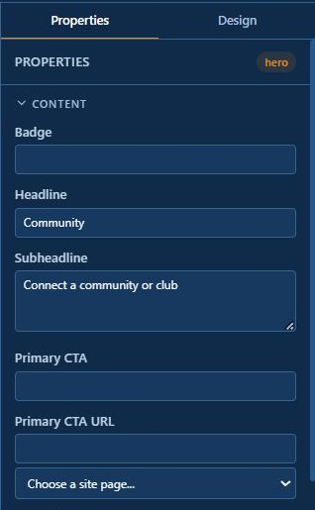
Figure 3. Example properties for a selected section.
Navbar: Logo Text and Logo Image URL identify the site; CTA Button and CTA Destination configure its action. Navigation destinations determine page or external links. Review links after changing page paths.
Footer: Logo, Description, Copyright and navigation fields control the footer. Copyright is user-entered text and can also carry a short credit. Minimal styling may omit the logo.
Hero: Badge, Headline, Subheadline, primary and secondary button labels and destinations, and image fields control the introductory section. Variant selects a supported layout.
Features: Section label, title, subtitle and feature items describe capabilities. Add and edit the individual entries; a heading alone does not populate a list.
CTA: Headline, supporting text, button text and destination form a call to action. Verify the destination.
Testimonials: Title, subtitle, entries, and variant control quotations. Supply real, authorized statements and attribution.
Stats, FAQ, Team and Logo Cloud: Edit the section title and each repeated statistic, question and answer, person, or logo label. Do not assume the entries have been fact-checked.
Content: Body accepts supported formatting. Use the available Bold, Italic, Heading, List, page-link and media-link controls for the selected text.
Image and Gallery: Choose or enter image references, titles and descriptions as offered. Alt text describes an image for people who cannot see it. Gallery items are managed individually.
Video: Supply a supported video URL, title and platform choice. Availability depends on that provider and the visitor's connection.
Strip and Banner: Strip controls blank spacing or the supported separator variants. Independent horizontal and vertical decorative lines are available separately in Components. Banner controls its text, link label and destination.
Document, Audio, local video and Document Library: Select supported project media and edit the relevant titles or descriptions. A visitor must still be able to retrieve the exported media.
PDF Viewer: Choose a PDF and set Title, Caption, Accessibility label, Height, Starting page, Fit mode and Mobile display. Available switches control thumbnails, search, print, download and fullscreen. Hiding a control does not make a publicly hosted PDF private.
Contact and Newsletter: Enter the requested labels, recipient or HTTPS service address, and consent text where available. A working form or subscription service must be configured separately. An email-draft option depends on the visitor sending the message.

Design panel
Theme preset: Applies a supported group of visual values to the project. Inspect all pages after changing it.
Colors and fonts: Change the available theme values for backgrounds, text, borders, and accents. Use readable contrast and verify any font on the intended system or host.
Responsive visibility: Supported sections can be hidden at selected screen widths. Hidden content can still exist in generated HTML; it is not a privacy control.

Media panel
When files match: Select reuse, keep separate, or skip for duplicate media before import. Matching uses file content within the project.
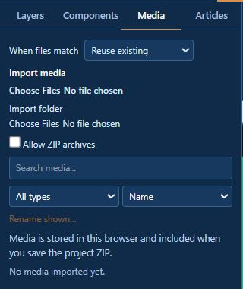
Figure 4. Media import and library controls.
Import media files: Select individual supported files. Review the import report for rejected or unsafe files.
Import folder: Select a folder of files through the folder picker. The original files are not intentionally modified.
Allow ZIP archives: Explicitly permits ZIP input when using the media import flow. Import limits and validation still apply.
Cancel: Requests cancellation of the current import. Already imported items remain.
Resume import and Discard list: Resume unprocessed items or discard the pending list. The pending list exists only while the app is open.
Search media, type filter, and sort: Narrow and order the media list. Search does not extract the contents of every document.
Rename shown and Undo renames: Rename displayed items using the offered operation, or reverse the supported last rename operation.
Preview PDF: Opens a preview of a PDF item. Add to page places a supported item through the relevant editing flow.
Replace and Undo replacement: Select a replacement for an existing media identity, or reverse the supported last replacement. Keep original files and project backups.

Articles panel
Make this page an article: Available on a selected non-Home page. Initializes article metadata while keeping page content editable.
Author: Enter the name to display with a ready article.
Summary and tags: Enter a short description and optional subjects used by supported article output.
Draft and Ready: Draft keeps the page in the project but excludes it from generated article output. Ready includes it in the next eligible export; it does not publish.

Settings screens
General > Site Name: Name used in supported site settings and output.
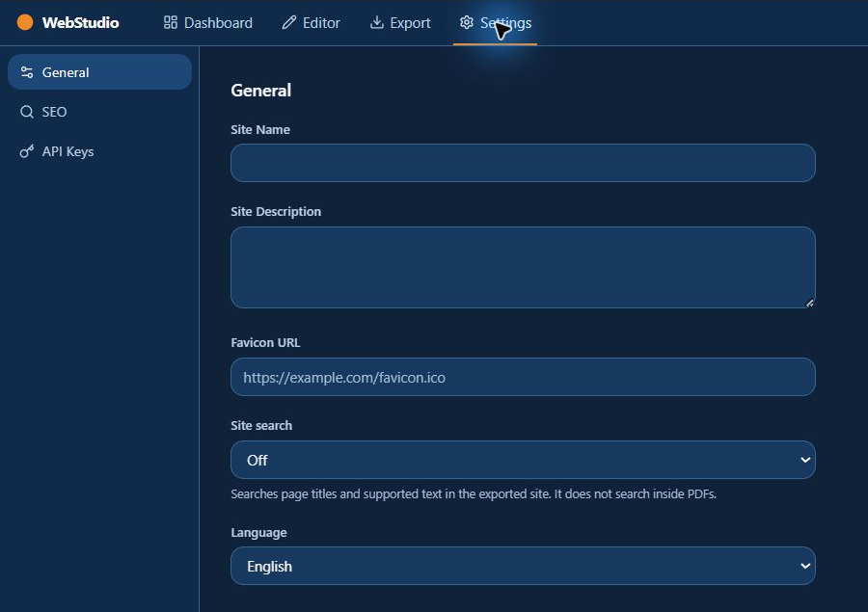
Figure 5. General site settings.
General > Site Description: Description used by supported metadata.
General > Favicon URL: Address of an icon. A remote address depends on the external host.
General > Site search: Enables or disables supported static site search. Search does not index all custom fields or the contents of PDFs.
General > Language: Sets the site's stored language value. It does not automatically translate the editor or website.
SEO > Page Title and Meta Description: Site-wide metadata and fallback values. Individual pages can have their own search details.
SEO > Public site URL: The expected public base address, including a required subfolder. It affects supported canonical and sitemap output; check the final host path.
SEO > OG Image URL: Address used for supported sharing metadata. A preview is illustrative and cannot control every search engine or social platform.
API Keys > cloud consent: Enables the optional cloud-generation path for the current session. A request can send its brief to the configured service.
API Keys > Gemini API Key: Enter a Google Gemini key for optional cloud generation. New entries currently last only for the session. Test contacts Google and does not guarantee model quota or billing.
API Keys > Deploy Access Key: Session credential for the configured legacy deployment endpoint. Do not add it to exported site content.
Remove older saved key controls: Remove the corresponding older stored credential when offered. Check the displayed result.

Export and local review
Export HTML or website ZIP: Generate the selected output. ZIP output is appropriate for multiple pages and media. The project file and website output are different artifacts.
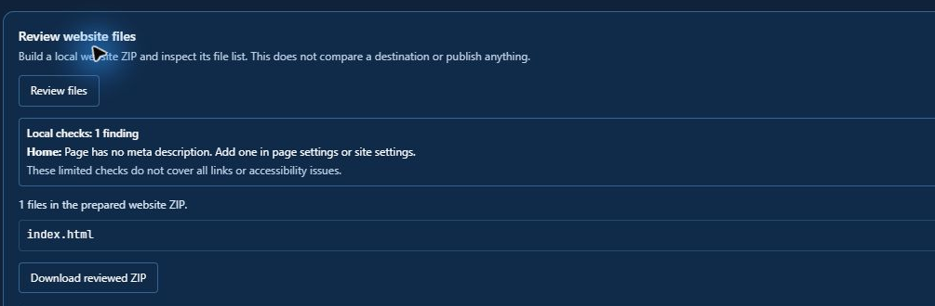
Figure 6. Local website file review.
Review website files: Builds a local review of the output and its file list. Review again after making changes.
Download reviewed ZIP: Saves the reviewed snapshot when it is still current.
Download file manifest: Saves the prepared list of output files and metadata for supported comparisons.
Compare previous manifest or destination scan: Select the matching file to compare. A destination scan represents the time at which it was captured; it is not a live guarantee.
Review restore plan: Compares supported backup and scan inputs. Review does not itself restore, delete, transfer, or publish files.
After export: Extract into a separate folder and test pages, links, images, PDF viewer, forms and responsive layout. Some browser features require a local web server rather than a file address.

Local AI dialog
Runtime ZIP: Browse to the supported separately obtained runtime archive.
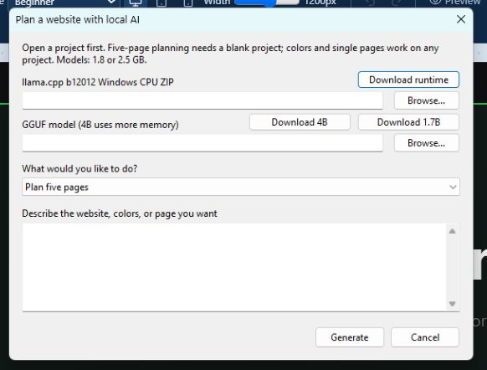
Figure 7. Optional local AI dialog.
Model file: Browse to a supported GGUF model. Runtime and model files require suitable disk space and system resources.
Brief: Describe the desired proposal. Avoid confidential content unless you intend it to be processed by the chosen service.
Proposal type: Choose the offered pages, page, or theme proposal. Available options depend on project state.
Generate and Cancel: Start the requested local operation or dismiss the dialog. Review any proposal before accepting. Generated text can be wrong.

SFTP and deployment review
Host and port: Identify the intended SFTP server. Confirm the destination with the administrator.
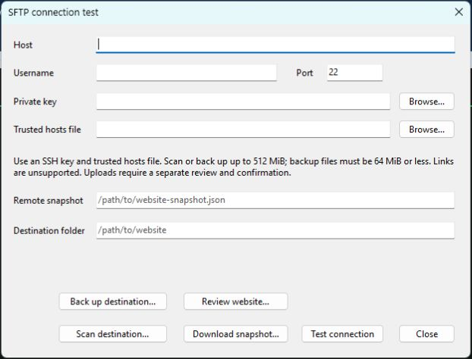
Figure 8. SFTP connection and review tools.
Username, private key, and trusted-hosts file: Supply the connection identity and host-verification information required by the dialog.
Test connection: Tests access without intentionally publishing files.
Scan destination and backup: Gather the supported destination inventory and recovery material as separate actions. Check each result and keep recovery files private.
Review and confirmation: Inspect the proposed file changes and the selected destination before any transfer. Transfer and rollback have failure and partial-completion risks. Do not publish until the owner explicitly instructs it.

Practical first project
Choose Start blank on the dashboard. Select Add page if another page is needed, enter its name and unique path, and confirm. Open Components and click or drag a section onto the active page. Select it on the canvas and use Properties to enter your own text and links. Use Layers to reorder or remove a section. Save the editable project, preview each page, and separately export a website ZIP for local inspection.

Adding decorative lines
Open the left Components panel. Expand Horizontal lines or Vertical lines to see the available samples. Choose thin solid, thick solid, dashed, dotted, or double, then click the desired position in a section. Press Esc to cancel placement. The line is a separate section object; selecting it reveals handles for resizing and a move cursor for repositioning.
Right-click the selected line and choose Properties to edit its direction, style, thickness, color, position, size, and layer order. Color uses the Windows color picker. The line is saved with the project and included in preview and generated HTML. Check tablet and phone previews as well as the desktop view.
The Strip component is a separate section for adding space or separating areas. Its blank, line, and dots variants are not the same as the independently positioned decorative line objects.

Selecting and arranging objects
Click a panel to select it. Double-click its text to edit it; Ctrl-click selects the item above a panel directly. In Layers, choose whether overlapping items select the panel first or the top item first. Right-click an object for its actions and properties.
Expand a section in Layers to select its objects. Drag a section object within that section list or use the arrow buttons to change its stacking order. The object context menu also provides Bring to front, Bring forward, Send backward, and Send to back. The layer list includes supported composite items and placed media.
Shift-click section objects to select several, including objects in different sections. Shift-drag across a blank canvas area to draw a selection rectangle. Drag a selected object to move the selected section objects together, use arrow keys to nudge, or Delete to remove them. A group movement across blocks is one undo step. Group selection does not include older placed media or composite items.

Saving and closing safely
Save project writes a project file, separate from website export. Wait until the status reports completion. If the current project has not changed since a confirmed save, closing the window or choosing Project > Exit does not ask to save again.
If changes are unsaved, choose Yes to save and close after the save succeeds, No to close without that save, or Cancel to return to the editor. Canceling or failing the save keeps the editor open. Changes made during a save still need to be saved before exit. A local draft or revision is not a substitute for a separate project file.

